**Restaurant Tip Calculator Project**

10 points Major Assessment

Due by the start of the period on **XX**

This project will allow you to use what you have learned so far, as well as learn how to do a couple of new things which will come in handy during units 2 and 3 😎. **You should each do your own project, but you can get (and should!) get help from your partner and other classmates if you get stuck! Coding is a collaborative sport!**

Your task is to create a “Restaurant Tip Calculator” program. [Here is the online tip calculator this problem is modeled after](https://www.calculator.net/tip-calculator.html). Create a TipCalculator class with a main method, then in your main method write your Tip Calculator program. Your program should welcome the user to the program then prompt the user to enter the number of people in their group eating at the restaurant (e.g. 6) and the tip percentage, as an integer, e.g. 20 for 20%, without the percentage sign.

After that, ask the user to enter various costs for items on the menu that they ordered, such as 12.95, 13.50, 20.95, etc. then enter “-1” when they are done entering all the costs. *This will require the use of a* while *loop, which we haven't explicitly learned yet,* but below is an example that you can copy/paste and play around with, then modify for your use:

Scanner scan = new Scanner(System.in);

System.out.print("Enter an EVEN integer: ");

int number = scan.nextInt();

// the while loop begins and repeats as

// long as the condition is TRUE; as soon

// as the condition becomes FALSE, it stops

while (number % 2 != 0) {

System.out.print("No silly, i said EVEN not odd! Try again: ");

number = scan.nextInt();

}

Your program should calculate and print the following information:

* The group’s total bill *before* tip
* The tip percentage
* The tip amount added to the bill
* The group’s total bill *including* tip
* Per person cost before tip
* Per person tip amount
* Per person total cost

All dollars and cents should be formatted properly, including decimal rounding. Use the DecimalFormat class to format each monetary value (**note:** if you already figured out a different way to round, please still use the DecimalFormat for this project since it's good practice with objects, which we are learning about next!). Here is how you can do this:

1. Add the following where you import Scanner: import java.text.DecimalFormat;
2. Similar to creating a Scanner object, create a DecimalFormat object with 2 decimal formatting precision, like this:

DecimalFormat formatter = new DecimalFormat("#.##");

1. Use the format method on the object by providing the double value you want to format as a parameter, then store the returned result as a String, like this:

double num = 12.458172109;

String formattedNum = formatter.format(num);

System.out.println(formattedNum);

**This will print: 12.46**

You might notice that any trailing zeros don't get printed; for example, 12.4007 will print as 12.4 rather than 12.40 -- that's OK!

**Sample program input/output (yours doesn't have to look exactly like this, but it can):**

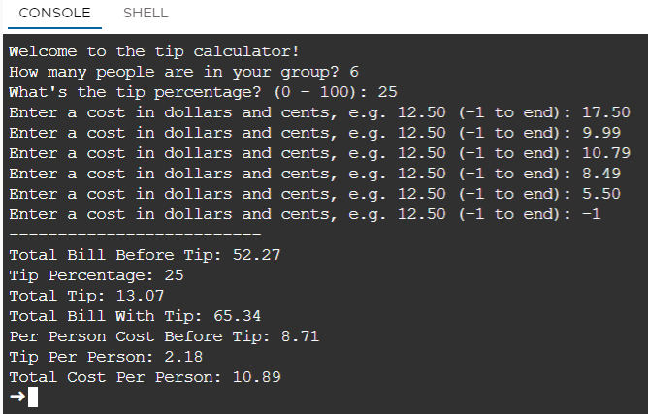

**Be sure to test your tip calculator thoroughly!**

|  |
| --- |
| **Step 1:**  **Before you start coding,** outline a plan on how you will approach this problem. Your plan should outline step-by-step what you plan to code up! Include:  - What variables you will need  - How you will calculate each value  - Where you will use the "while loop"  - How all your data will be formatted and printed  **Document your plan below:** |
|  |

|  |  |
| --- | --- |
| **Step 2: Before you start coding,** get feedback on your plan from a neighbor in class. Can you find any missing steps? Can you see any issues with approaching the problem? Is there anything unclear or something they should think about?  **Have your neighbor provide feedback in the space below!** | |
| **Partner name:** |  |
| Write the feedback here! | |

**Step 3: Begin coding! Be sure you are using a new IntelliJ project for this. As your work, discuss with your partner and classmates any issues you run into!**

**Step 4: TEST TEST TEST! Think you are done? TEST AGAIN!**

**Step 5: FEEDBACK:** Have your partner test your **final** program, look at your code, and provide a suggestion for what might be improved in terms of either the code *or* the program's functionality/output. Then, if you agree with their feedback, incorporate their suggestion (it is up to you as the programmer whether you take the suggestion or not!). Capture their suggestion below:

|  |  |
| --- | --- |
| Partner's Name: |  |
| Suggestion for improvement from my partner: |  |
| Did you incorporate their suggestions? Why or why not? |  |

**Self-score Kaufman’s**

**below: Scores**

|  |  |  |
| --- | --- | --- |
| **SCORING RUBRIC (1 point each)** | | |
|  | Initial written plan is complete and my partner has provided feedback on that plan. |  |
|  | Program welcomes the user. |  |
|  | Program asks for the number of guests and tip percentage (both as whole numbers). |  |
|  | A Scanner object is created and correct methods are used to obtain all user input. |  |
|  | User is prompted to enter costs in dollars and cents, and can do so repeatedly until -1 is entered. |  |
|  | After the user enters the last cost, the program prints out all the required values. |  |
|  | Decimals are formatted with 2 decimal places using a DecimalFormat object. |  |
|  | Variables are appropriately used, are named using proper conventions, and are of appropriate data types. |  |
|  | Code is properly indented *and* multiple comments are added to indicate what significant parts of the program does. |  |
|  | Partner has tested my program and provided a suggestion, which I captured in the above and either incorporated or not (with explanation). |  |
|  | **TOTAL (out of 10)** |  |

**SUBMISSION:**

1. Paste a link to your final project code on GitHub in the box below (be sure your **final** code is saved there!) -- *note that your project cannot be graded without this link!*

|  |
| --- |
|  |

1. Complete the partner suggestion table above and rubric self-score column, then submit this document in Google Classroom.